Learning Journal Unit 6

Godfrey Ouma
University of the People
MATH 1280: Introduction to Statistics
Esther Pearson
October 19, 2023

Learning Journal Unit 6
We are given the random variable X that follow an exponential distribution such as: $X\sim Exp\left(\frac{1}{9.848}\right)$
- Find the expected value
$μ=\frac{1}{m}$
$μ=\frac{1}{\left(\frac{1}{9.848}\right)}=9.848$
- Find the standard deviation
$μ=σ=9.848$
- Find $P(X<12)$
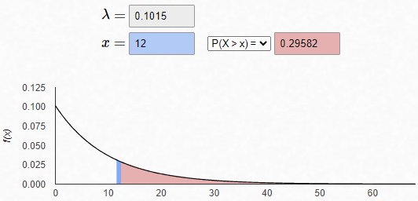
$P(x > 12) = 1 – P(x < 12)$
Since $P(X < x) = 1 –e^{-mx}$, then $P(X > x) = 1 –(1 –e^{-mx}) = e^{-mx}$
$e^{-mx}=e^{-\left(1/{9.848}\right)*12}≈0.2957$
Therefore, the probability that$x$ is more than 12 is 0.2957.
- Find $P(8<X<14)$
$P(8< x < 14) = P(x < 8) – P(x < 14)$
$P(X < 8) = 1 –e^{-mx}={1-e}^{-\left(1/{9.848}\right)*8}≈0.5562$
$P(X < 14) = 1 –e^{-mx}={1-e}^{-\left(1/{9.848}\right)*14}≈0.7587$
$P\left(x < 8\right)– P\left(x < 14\right)=0.7587-0.5562=0.2025$
Therefore, the probability that$x$ lies between eight and fourteen is 0.2025.

